Case Study Report

# Data Analytics with Power BI

**“360-degree Business Analysis of**

**Online Delivery Apps”**



**Tech Saksham**

**“S.T. Hindu College”**

|  |  |
| --- | --- |
| **NM ID** | **NAME** |
| D68E3E5391ECB37847246C7E6CC717DA | ASHIKA .S |

R. Uma Maheshwari

Master Trainer

# ABSTRACT



This paper presents a comprehensive 360-degree business analysis of Zomato's delivery application utilizing Power BI, a powerful business analytics tool. Through data visualization and insights derived from various dimensions such as customer behavior, delivery patterns, restaurant performance, and market trends, this analysis aims to provide a holistic understanding of Zomato's delivery ecosystem. By leveraging Power BI's capabilities, we delve into key metrics including order volumes, delivery times, customer satisfaction ratings, and revenue trends to uncover actionable insights for optimizing operational efficiency, enhancing customer experience, and driving business growth. The integration of advanced analytics techniques within Power BI allows for predictive modeling and trend forecasting, enabling Zomato to anticipate market shifts, tailor marketing strategies, and make informed decisions to stay competitive in the dynamic food delivery landscape. This study underscores the significance of leveraging data-driven insights through Power BI to drive strategic decision-making and foster sustainable growth in the on-demand delivery industry.



## INDEX

|  |  |
| --- | --- |
| **Sr. No.** | **Table of Contents** |
| 1 | Chapter 1: Introduction |
| 2 | Chapter 2: Services and Tools Required |
| 3 | Chapter 3: Project Architecture |
| 4 | Chapter 4: Modeling and Result |
| 5 | Conclusion |
| 6 | Future Scope |
| 7 | References |
| 8 | Links |



**CHAPTER 1**

## INTRODUCTION

### 1.1 Problem Statement

This analysis aims to delve into various facets of Zomato's delivery ecosystem, including but not limited to order volumes, delivery times, customer satisfaction metrics, restaurant performance, and market trends. By leveraging the power of Power BI, Zomato seeks to extract actionable insights from vast volumes of data generated by its delivery apps to enhance operational efficiency, optimize delivery routes, improve customer experience, identify growth opportunities, and make data-driven decisions to maintain its position as a leader in the food delivery industry. This project will involve integrating data from multiple sources, designing interactive dashboards, and implementing advanced analytics techniques to provide stakeholders with a holistic view of Zomato's delivery operations, thereby empowering them to strategize effectively and drive sustainable growth in a competitive market environment.

### 1.2 Proposed Solution

Utilizing Power BI's robust visualization tools, interactive dashboards will be designed to provide stakeholders with real-time insights into key performance metrics such as order volumes, delivery times, and customer feedback. Advanced analytics techniques, including predictive modeling and machine learning algorithms, will be employed to forecast demand, optimize delivery routes, and personalize the user experience. Additionally, geospatial analysis will be conducted to identify areas with high demand and potential expansion opportunities. Regular monitoring and performance tracking will be facilitated through automated alerts and customizable reports, enabling proactive decision-making and continuous improvement. By harnessing the power of Power BI, this solution aims to empower Zomato with actionable insights to drive operational efficiency, enhance customer satisfaction, and maintain its competitive edge in the everevolving food delivery landscape.

### 2.1 Feature

1.Sales performance dashboard with trends over time and regional analysis.

1. Customer segmentation by behavior and demographics for targeted marketing.
2. Delivery performance monitoring with time analysis and agent efficiency.
3. Restaurant partner analysis including revenue metrics and satisfaction ratings.
4. Menu analysis to track popular dishes, trends, and profitability.
5. Financial analysis with revenue, expenses, and forecasting.
6. Operational efficiency dashboard for process optimization and SLA tracking.
7. Market trends and competitor analysis for strategic planning.
8. Geospatial analysis for customer distribution and route optimization.
9. Executive summary dashboard for high-level insights and recommendations.

### 2.2 Advantages

1. **Comprehensive Insights**: Power BI consolidates data for a holistic view of user interactions, delivery performance, feedback, and market trends.
2. **Real-time Monitoring:** Instant tracking of KPIs like order volume and customer satisfaction ratings facilitates quick decision-making.
3. **Data Visualization:** Interactive dashboards and reports simplify the identification of trends and patterns.
4. **Predictive Analytics:** Machine learning algorithms enable forecasting of demand fluctuations and optimization of delivery routes.
5. **Cost Optimization:** Identifies opportunities for reducing operational costs and improving profitability.
6. **Enhanced Customer Experience:** Tailors services based on customer preferences and feedback.

### 2.3 Scope

Conducting a comprehensive 360-degree business analysis of Zomato delivery apps using Power BI presents an exciting opportunity to delve deep into the operational dynamics, customer behaviors, and market trends shaping the food delivery industry. With Power BI's robust analytics capabilities, one can explore various dimensions of Zomato's business, including order volumes, delivery times, customer satisfaction metrics, and revenue streams. By leveraging Power BI's intuitive dashboards and data visualization tools, analysts can uncover actionable insights to optimize delivery operations, enhance customer experiences, and drive business growth.

At the operational level, Power BI can provide real-time visibility into key performance indicators such as order processing times, delivery fleet efficiency, and restaurant partner performance. By analyzing historical data trends and patterns, stakeholders can identify operational bottlenecks, streamline processes, and improve resource allocation to ensure timely and efficient deliveries.

Customer behavior analysis is another critical aspect that Power BI can illuminate. Through advanced analytics techniques like segmentation and cohort analysis, analysts can gain a deep understanding of customer preferences, ordering habits, and satisfaction levels. This knowledge can inform targeted marketing campaigns, personalized recommendations, and loyalty programs aimed at enhancing customer retention and lifetime value.

Moreover, Power BI's geographical mapping capabilities can offer valuable insights into market trends and competitive dynamics. By visualizing customer density, delivery coverage areas, and competitor presence, stakeholders can identify lucrative growth opportunities, optimize delivery routes, and make informed expansion decisions.

Overall, a 360-degree business analysis of Zomato delivery apps using Power BI holds immense potential to unlock actionable insights that drive operational efficiency, enhance customer satisfaction, and fuel strategic decision-making in the fiercely competitive food delivery landscape.

## CHAPTER 2 SERVICES AND TOOLS REQUIRED

**2.1 Services Used:**

1. **Zomato API:** Access to Zomato's data through their API would be crucial for extracting information related to orders, delivery times, customer feedback, restaurant performance, etc.
2. **Power BI**: Microsoft Power BI is the primary tool for data visualization, analysis, and reporting. It allows you to connect to various data sources, prepare and clean data, and create interactive dashboards and reports. **3. Data Preparation Tools**: Tools like Microsoft Excel, Power Query (integrated into Power BI), or SQL for data cleaning, transformation, and modeling. These tools are essential for preparing the raw data obtained from Zomato's API for analysis.
3. **Data Visualization Libraries:** Besides Power BI, you might use additional data visualization libraries or tools like D3.js or Plotly.js for creating custom visualizations or enhancing the visual appeal of your reports.
4. **Cloud Storage:** If you're dealing with large datasets, cloud storage solutions like Amazon S3, Google Cloud Storage, or Azure Blob Storage can be used to store and manage the data securely.

### 2.2 Tools and Software used

**Tools**:

* **Power BI**: The main tool for this project is Power BI, which will be used to create interactive dashboards for real-time data visualization.

* **Power Query**: This is a data connection technology that enables you to discover, connect, combine, and refine data across a wide variety of sources.

**Software Requirements**:

* **Power BI Desktop**: This is a Windows application that you can use to create reports and publish them to Power BI.

* **Power BI Service**: This is an online SaaS (Software as a Service) service that you use to publish reports, create new dashboards, and share insights.

* **Power BI Mobile**: This is a mobile application that you can use to access your reports and dashboards on the go.

**CHAPTER 3**

## PROJECT ARCHITECTURE

### 3.1 Architecture

A high-level architecture for the project:

1. **Data Collection**: 360-degree Business Analysis of Online Delivery Apps is collected from various sources like bank transactions, customer interactions, Company data etc.
2. **Data Storage**: The collected data is stored in a database for processing.
3. **Data Processing**: The stored data is processed usual information like restaurant details, online delivery and restaurant rating.
4. **Data Visualization**: The processed data and the results from the predictive models are visualized in real-time using Power BI. Power BI allows you to create interactive dashboards that can provide valuable insights into the data.
5. **Data Access**: The dashboards created in Power BI can be accessed through Power BI Desktop, Power BI Service (online), and Power BI Mobile.

**CHAPTER 4**

## MODELING AND RESULT

### Transform data

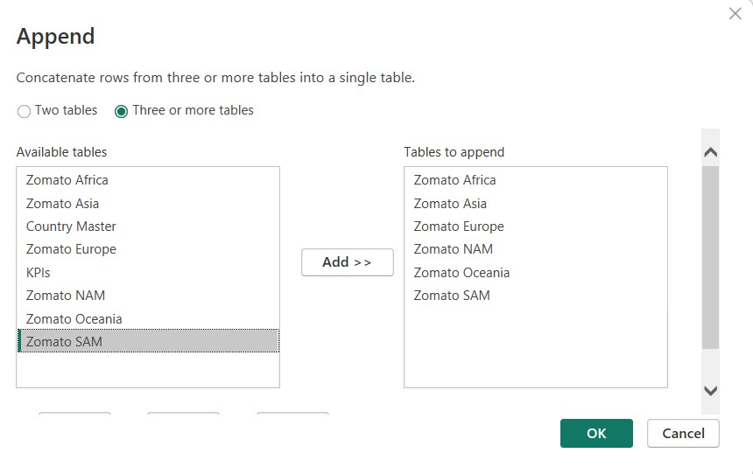

Append the data source, Zomato Africa, Zomato Asia, Zomato Europe, Zomato NAM, Zomato Oceania, Zomato SAM into a new data source. The new data source was renamed ‘Zomato Global’. Then the other sub data source was disabled.

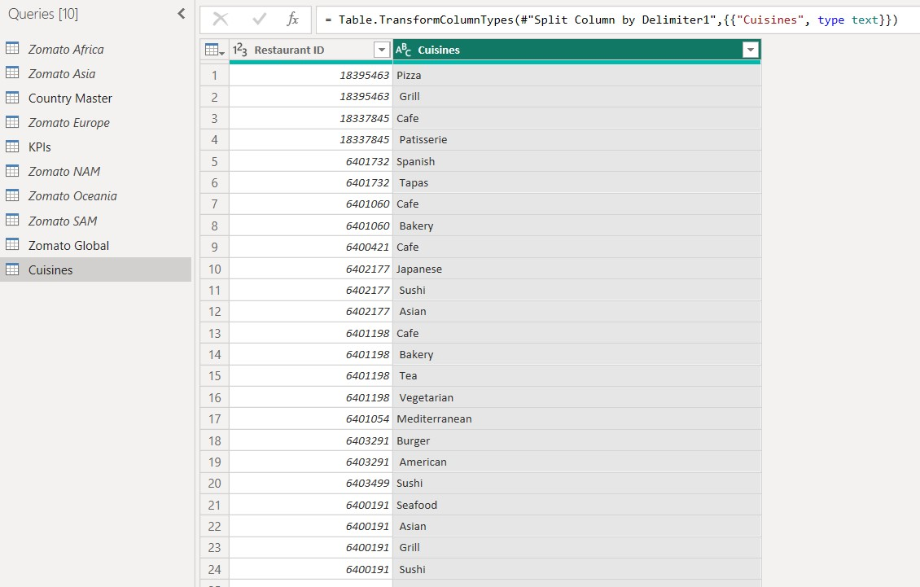

Duplicate the Zomato Global Data source then remove the all columns except Restaurant ID and Cuisines. Renamed the new data into Cuisines. Then split the column cuisines by delimiter format.

Modified relationship

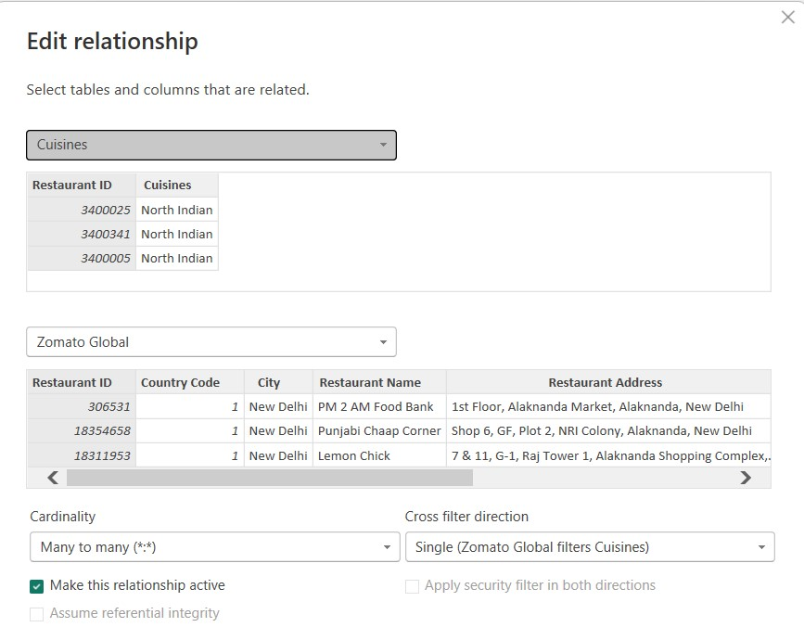

Remove the Restaurant ID relationship between Fact Table to Cuisines and merge new Restaurant ID relationship between Zomato Global to cuisines in ‘many to many’ format.

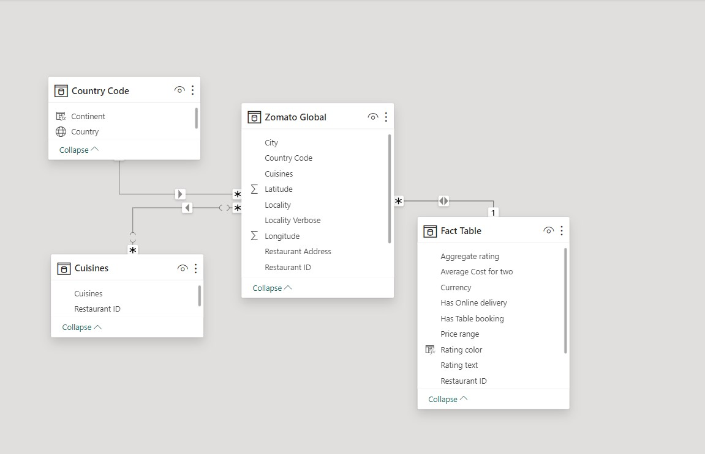

The above model view image shows the relationship of the full data base Zomato Global database to other data sets Fact Table, Country Code, Cuisines.

#### Modelling rating color

Notice that the Rating color are missing from the Fact table data. These can be formulated from the Aggregate rating column in the fact table by give four color value like red, orange, green, dark green to separate value of Aggregate rating.

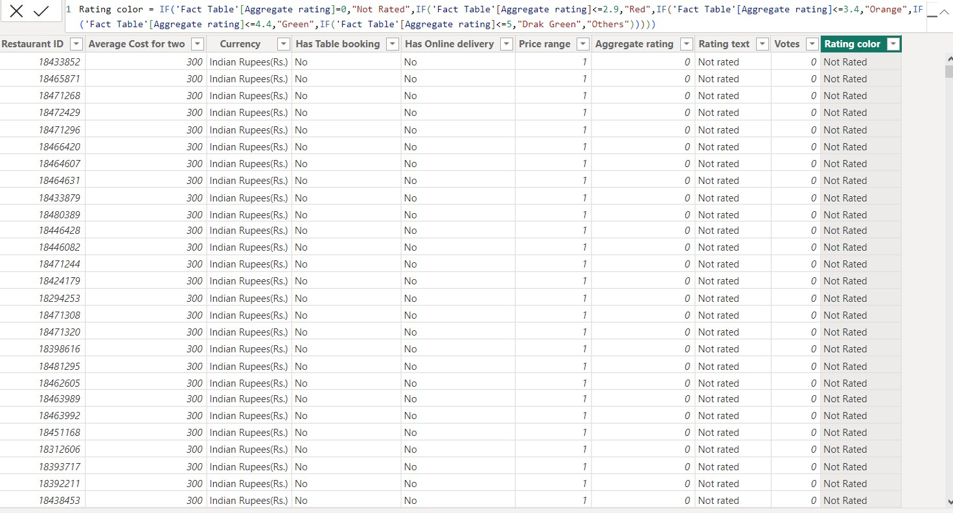

Apply the colors, show Not Rated to the Aggregate value ‘0’, Red for the values<=2.9, Orange for the values<=3.4, Green for the values<=4.4, Dark green for the values<=5 and other values.

#### Creating new measurements

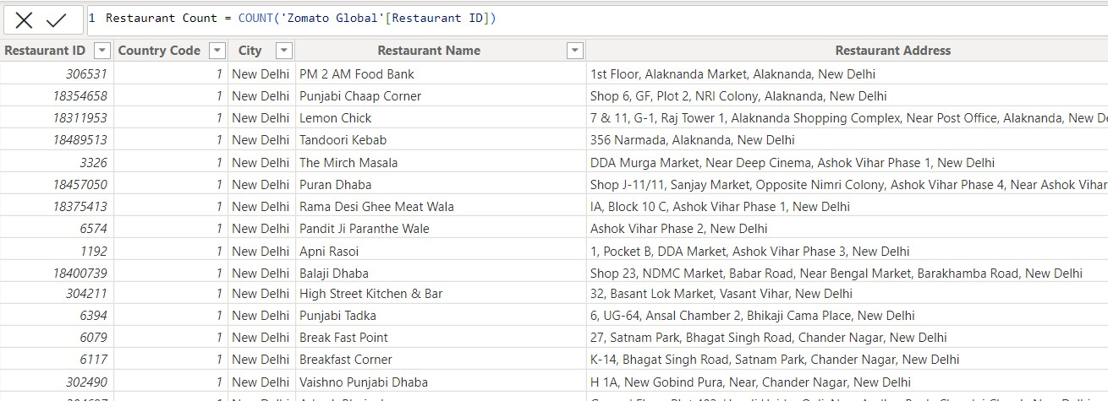

Create new measurement ‘Restaurant Count’ using count function to the Restaurant ID in the Zomato Global data source.

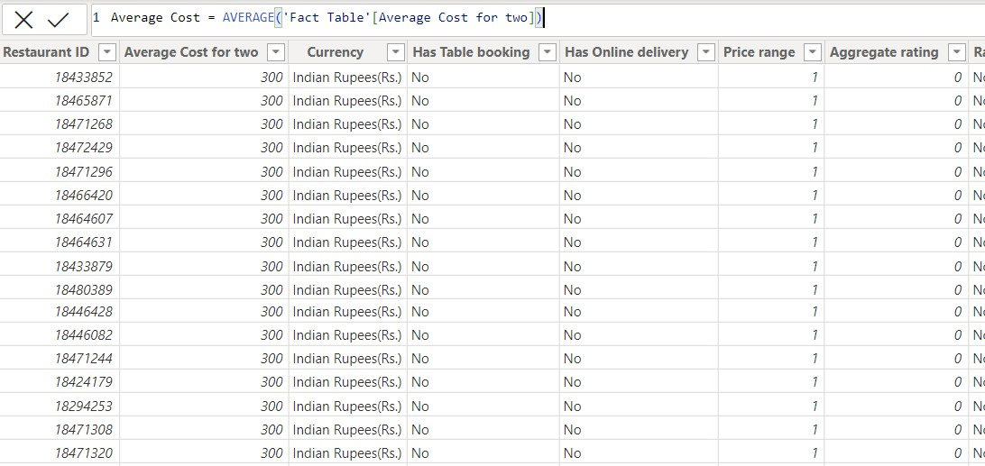

Creating new measurement ‘Average Cost’ by using average function ‘Average Cost for two’ table in the fact table data source.

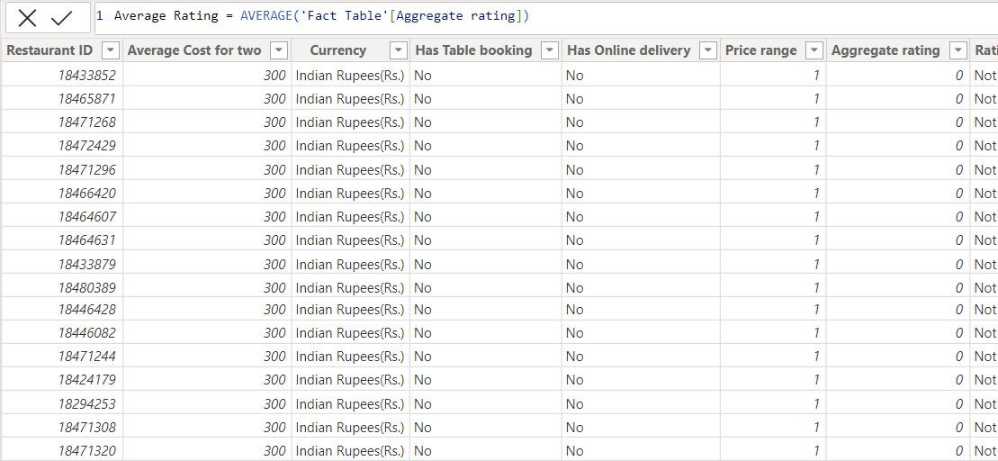

Creating new measurement ‘Average Rating’ by using average function to ‘Aggregate rating’ table in the fact table data source.

## Dashboard

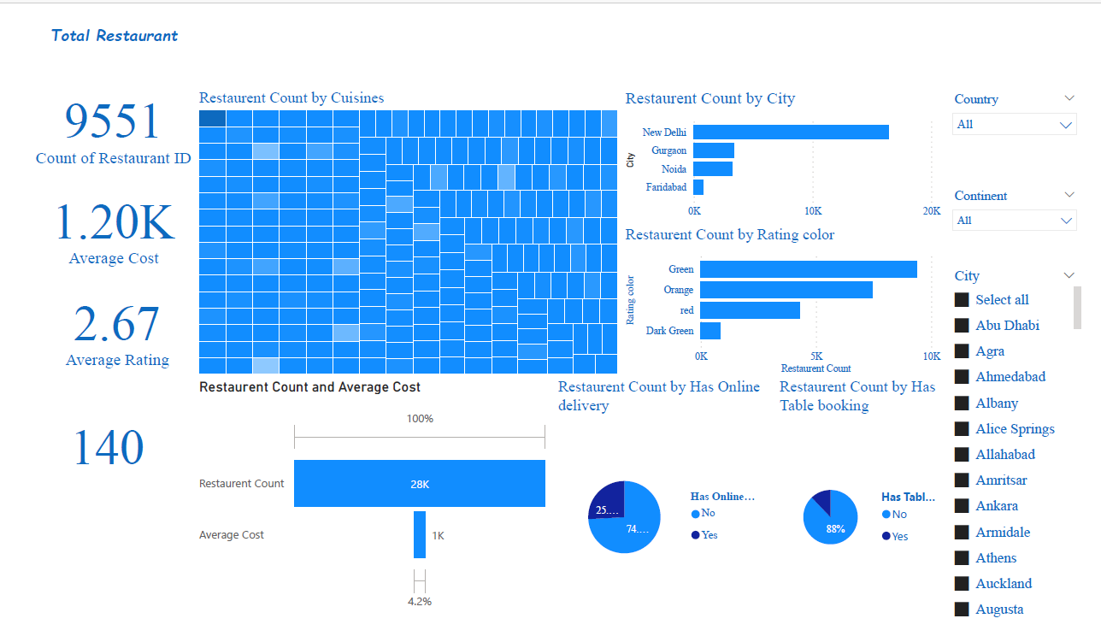

### CONCLUSION

In conclusion, conducting a 360-degree business analysis of Zomato Delivery

Apps utilizing Power BI has provided invaluable insights into various facets of its operations. By leveraging Power BI's robust analytics capabilities, Zomato has been able to gain a comprehensive understanding of its delivery ecosystem,

including customer behavior, delivery efficiency, market trends, and performance metrics. Through the visualization of data-driven insights, Zomato can make informed decisions to enhance user experience, optimize delivery routes,

streamline operations, and ultimately drive business growth. The integration of

Power BI into Zomato's analytical framework exemplifies the power of leveraging advanced data analytics tools in today's competitive market landscape, enabling companies to stay agile, responsive, and customer-centric in their approach to business management and decision-making.

### FUTURE SCOPE

Firstly, enhancing the depth and breadth of data analysis can provide invaluable insights into customer behavior, preferences, and trends. By integrating data from various sources such as order history, customer feedback, and demographic information, Zomato can gain a comprehensive understanding of user preferences and tailor its services accordingly. This could involve optimizing delivery routes, refining menu offerings, or implementing targeted marketing strategies to maximize customer satisfaction and retention.

Moreover, predictive analytics powered by Power BI can enable Zomato to forecast demand more accurately, thereby optimizing inventory management and resource allocation. By identifying patterns and correlations in historical data, the platform can anticipate peak ordering times, seasonal fluctuations, and popular cuisine trends, ensuring efficient operations and minimizing wastage. Furthermore,

Additionally, incorporating machine learning algorithms into the analysis pipeline can unlock even deeper insights, such as personalized recommendation engines, fraud detection mechanisms, and dynamic pricing models. By continuously learning from new data inputs and user interactions, these models can adapt and evolve over time, further enhancing the platform's competitiveness and value proposition.

the scope for business analysis using Power BI within Zomato's delivery ecosystem will only expand. By staying at the forefront of analytics innovation and leveraging the full potential of their data assets, Zomato can not only drive operational excellence but also foster sustainable growth and differentiation in an increasingly competitive market landscape.

**REFERENCES**

<https://www.spec-india.com/blog/power-bi-dashboard-examples>

### LINK